**Entering data (Personal note: Maya, you can ignore)**



**Locomotor**

ID check

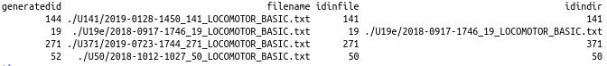

**Lever training**

Line 8 inconsistency in the following three files:



2018-0718-1107_2_LEVER TRAINING (2).plx

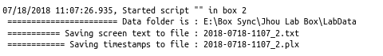

**Progressive Punishment**

ID check

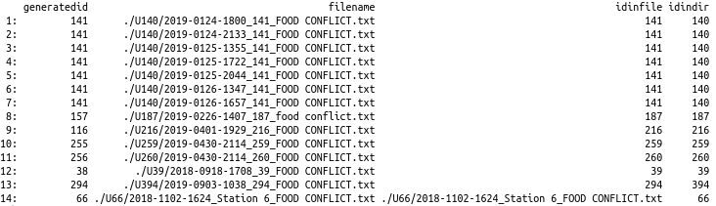

Session order is not consistent



For example, from the Master file

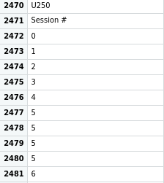

# of trials at last Shock Intensity??? -- which block, attempted or complete

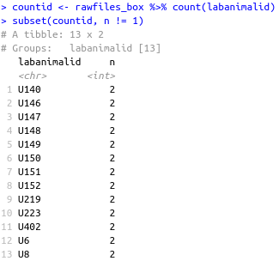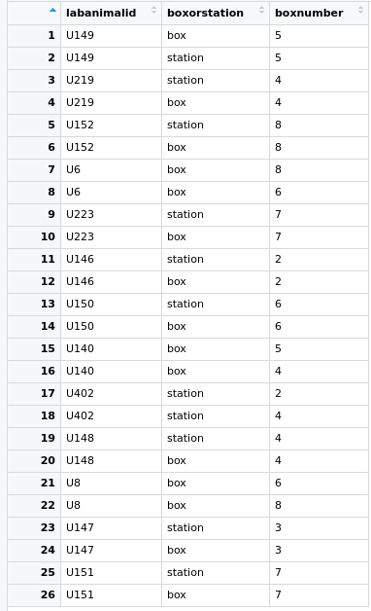

While asking about station vs box, clarify why some rats have inconsistent box information

**Progressive Ratio**



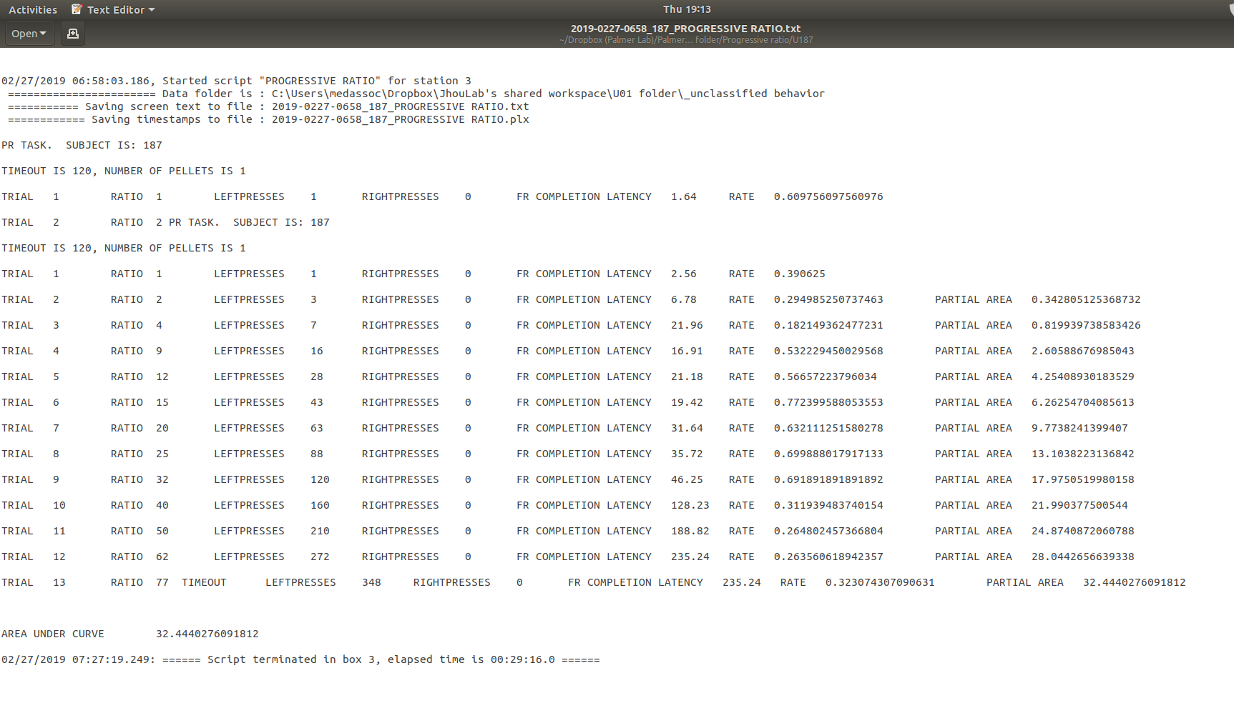

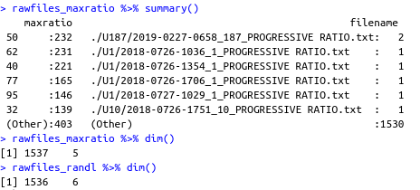

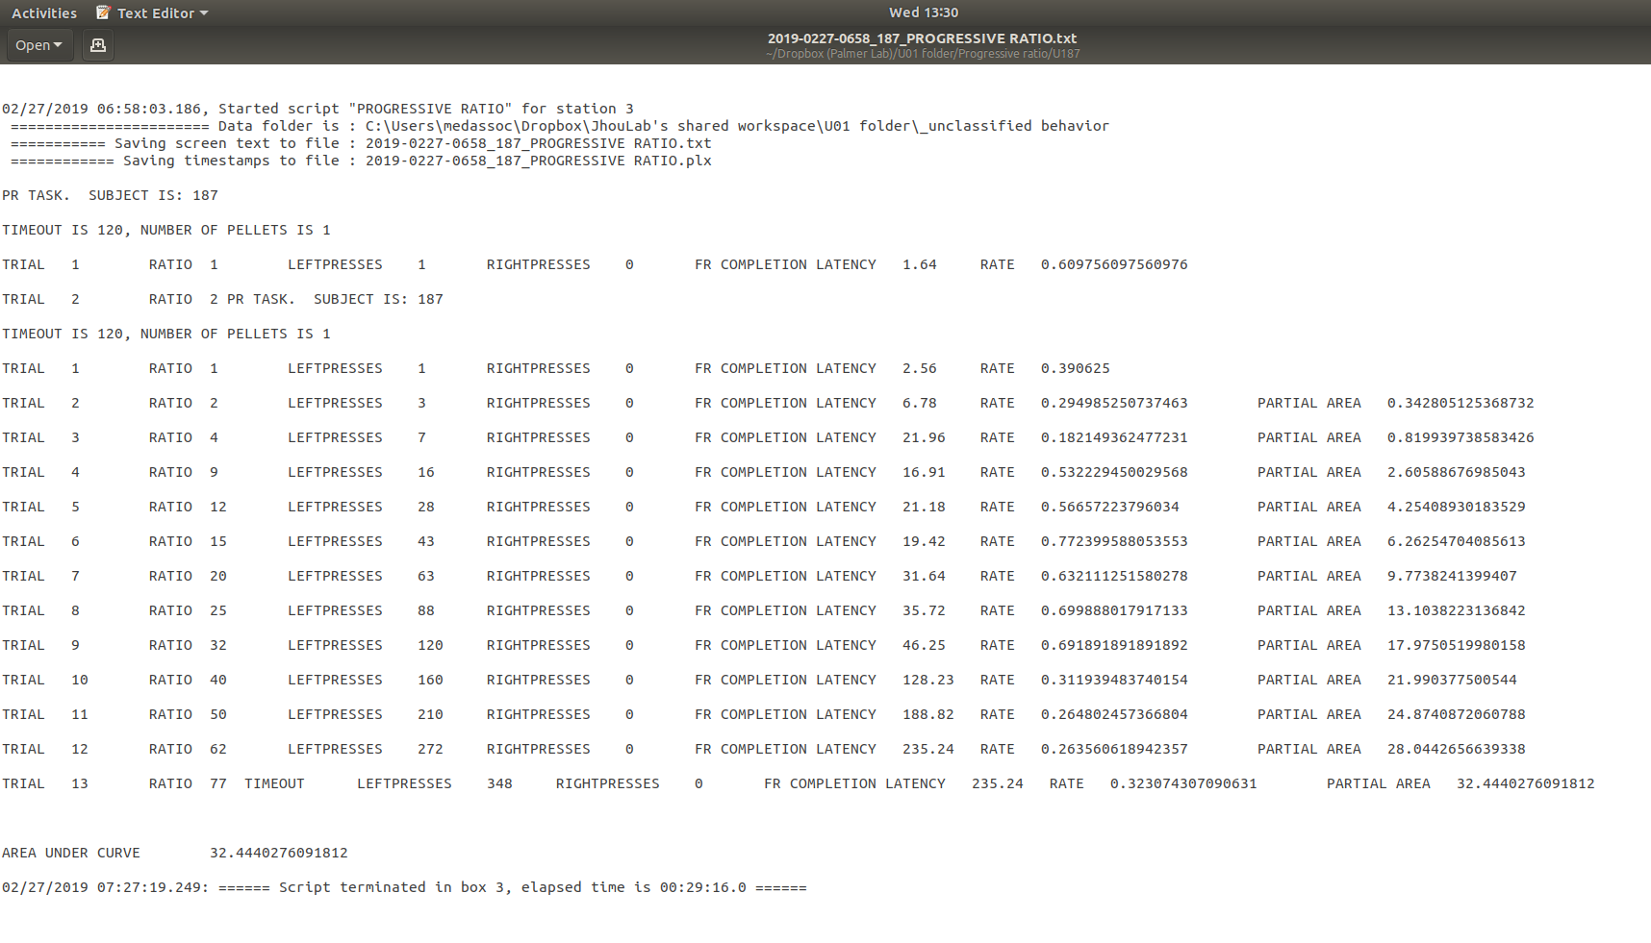

Why does this session have two timeout values?

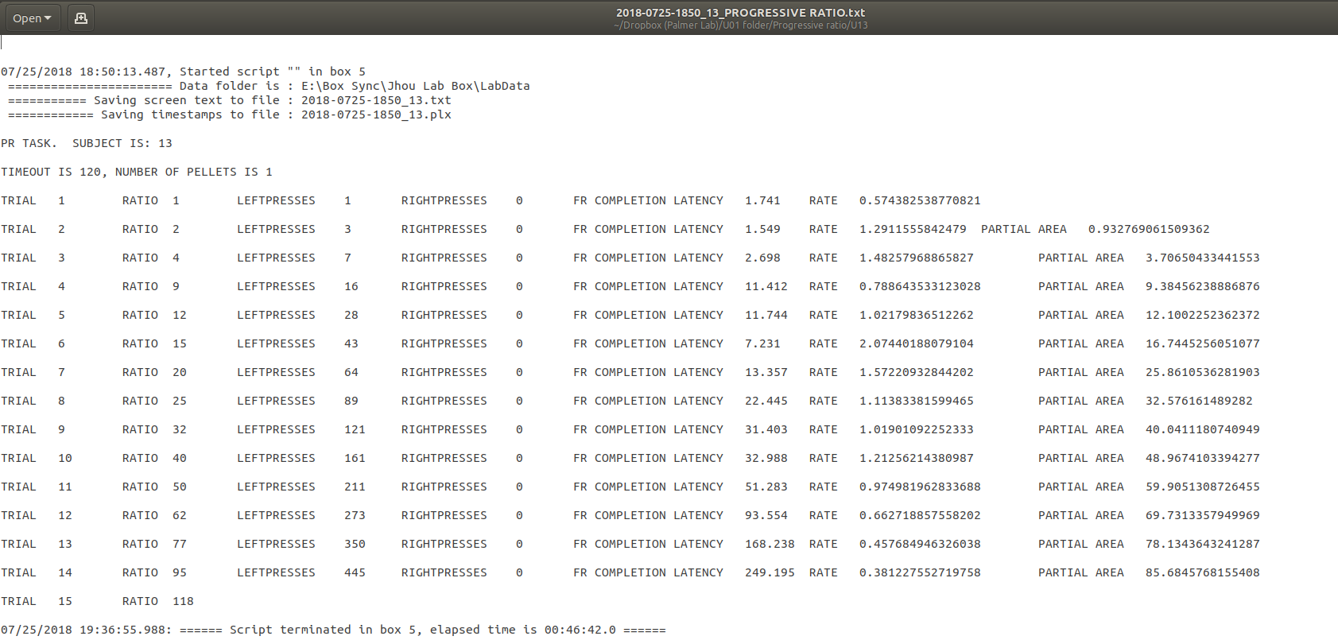

No TIMEOUT VALUE

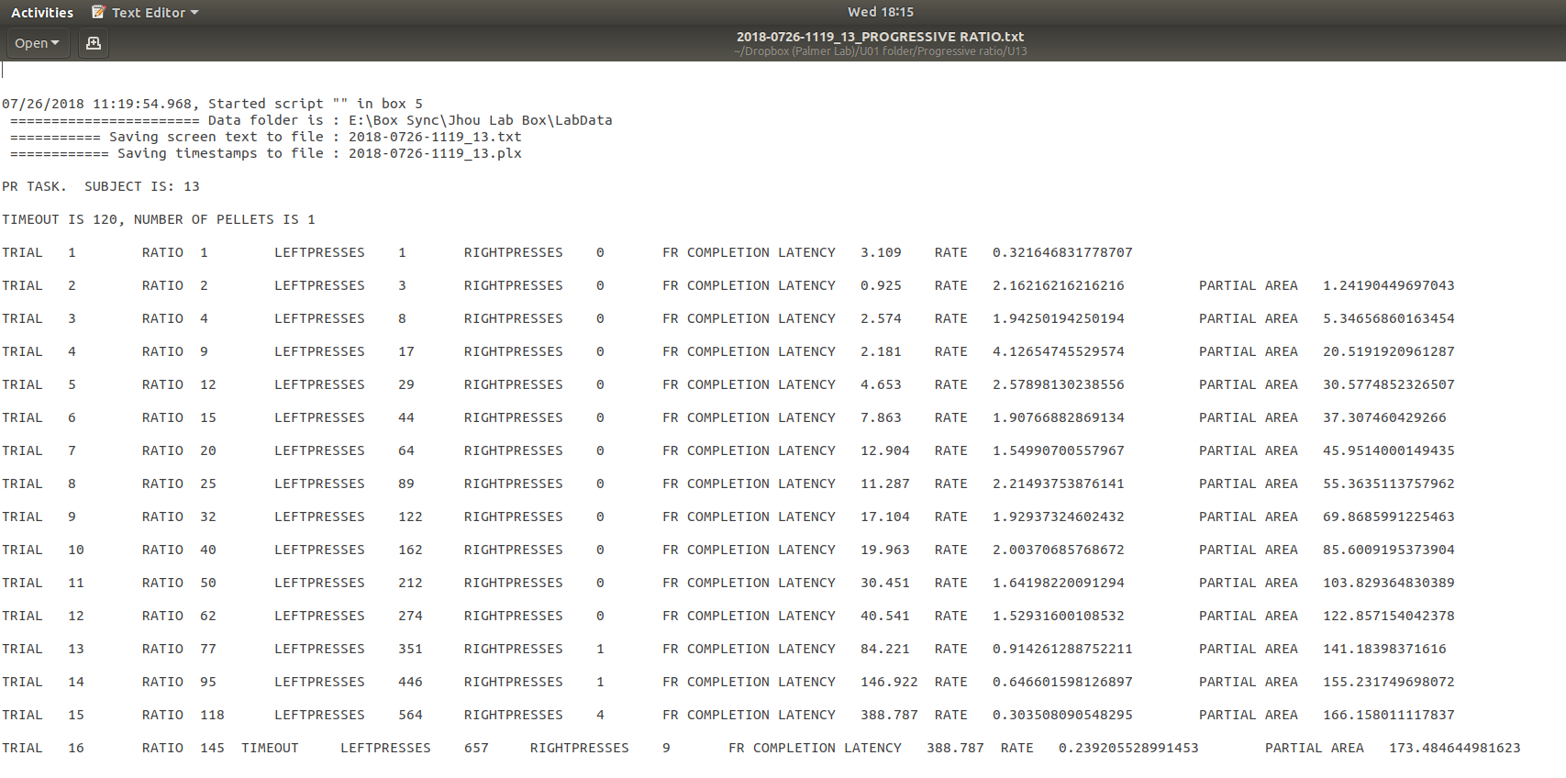

Extract last value with TIMEOUT?

10/28 Apart from the error files, what is wrong with the other files

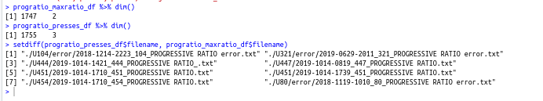

Progressive punishment different formats

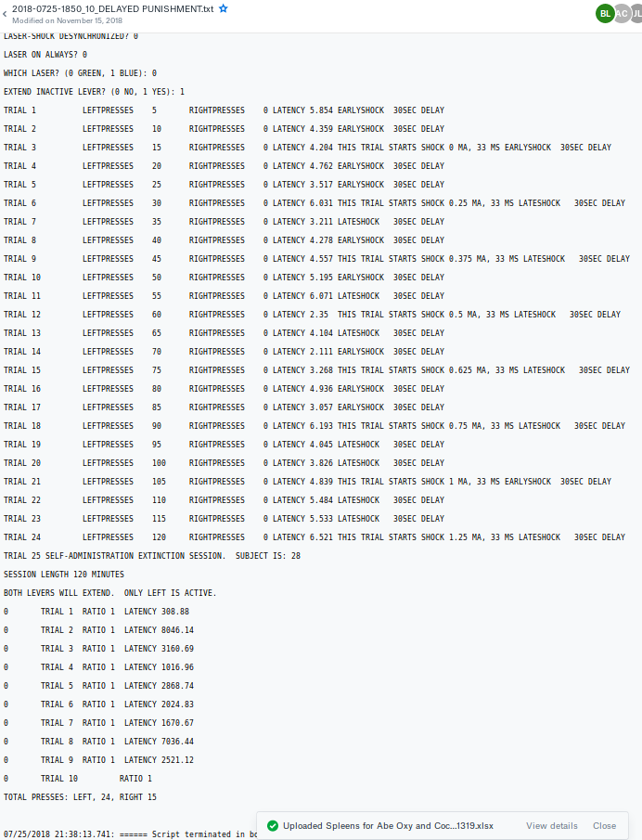

Cannot extract the delay because of some misformatting

Number of left presses between last two !=4 because of misformatting

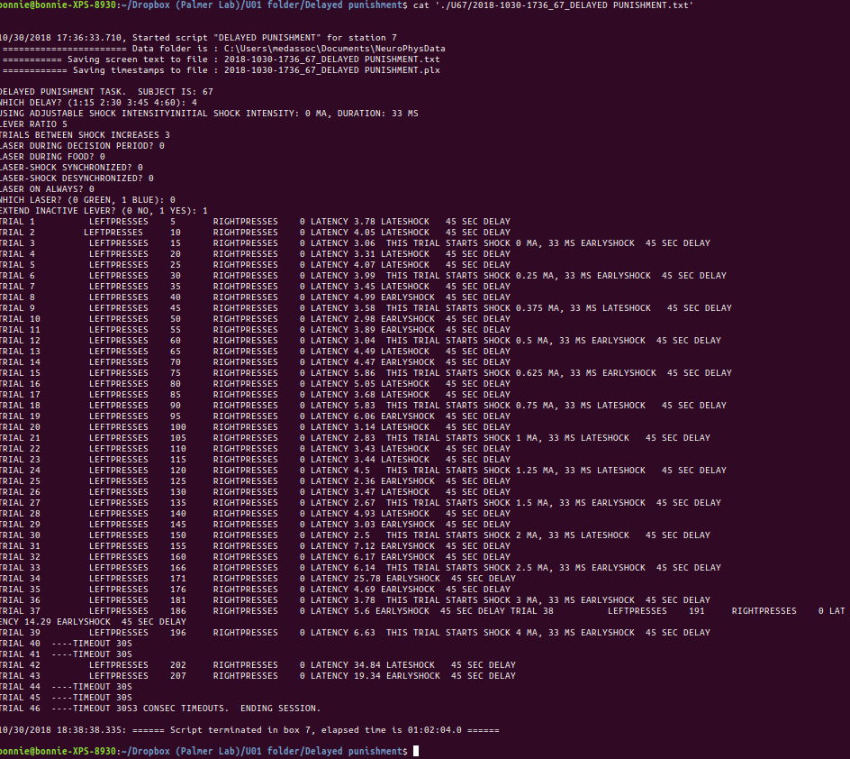



**Runway**

How to attain Habituation data?

Format inconsistency

Line 8 contains more than just the generatedid

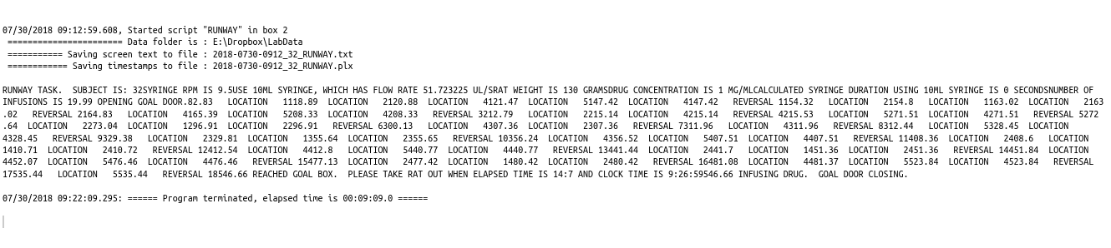

Above inconsistency occurs in two files



Both 451 and 32 have 0 seconds (duration of syringe?)

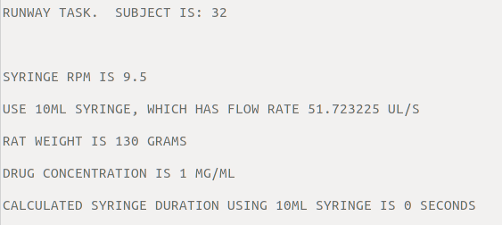

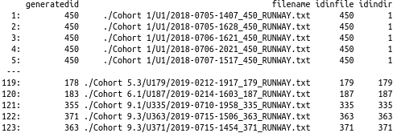

Too many – make sure to include the runwaymisID.csv in email

How to populate the table from the raw files.

For example, to collect the information for the following animal:

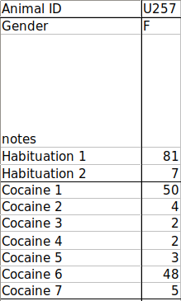

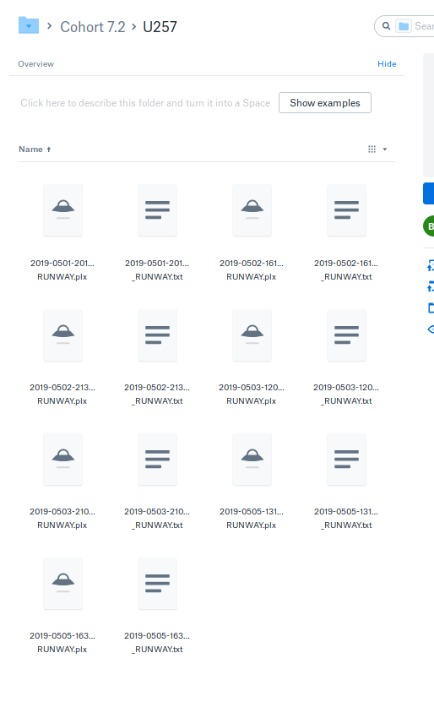

For session 1, I would open the first file and take....

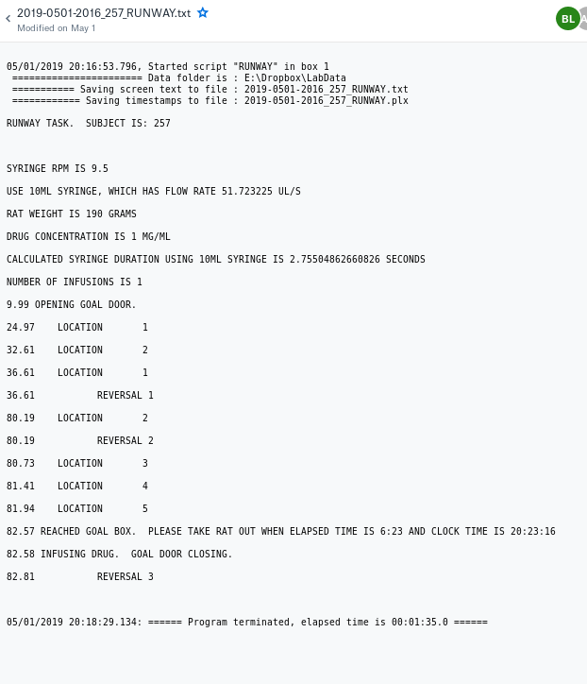

For session 2, I would open the first file and take....

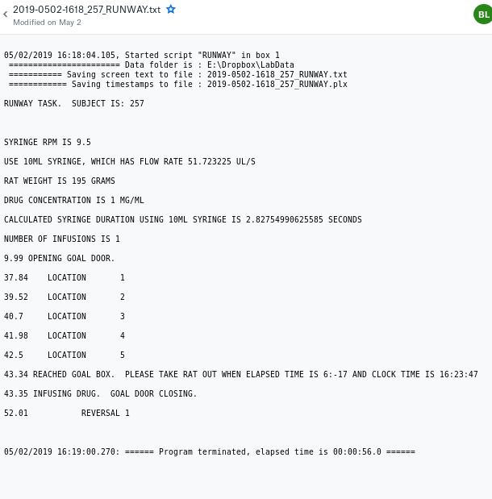

To extract the reversal, is it the case that we will always have one reversal after the animal reached the goal box?

Tabs, spaces, etc

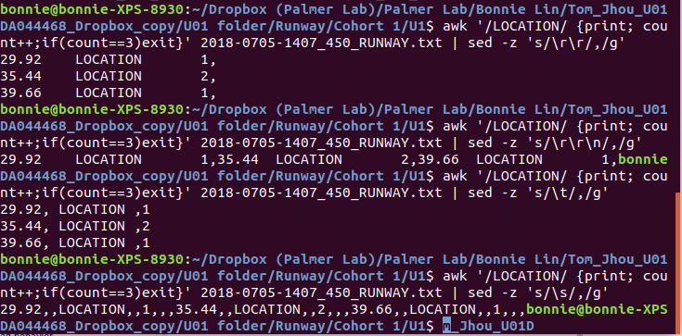

**Delayed Punishment**

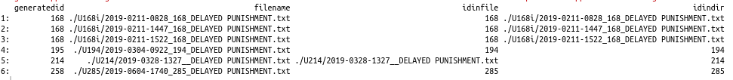

Formatting of some files are creating issues for $NF code for extracting delay information: 0 or 1 (which stands for 15)

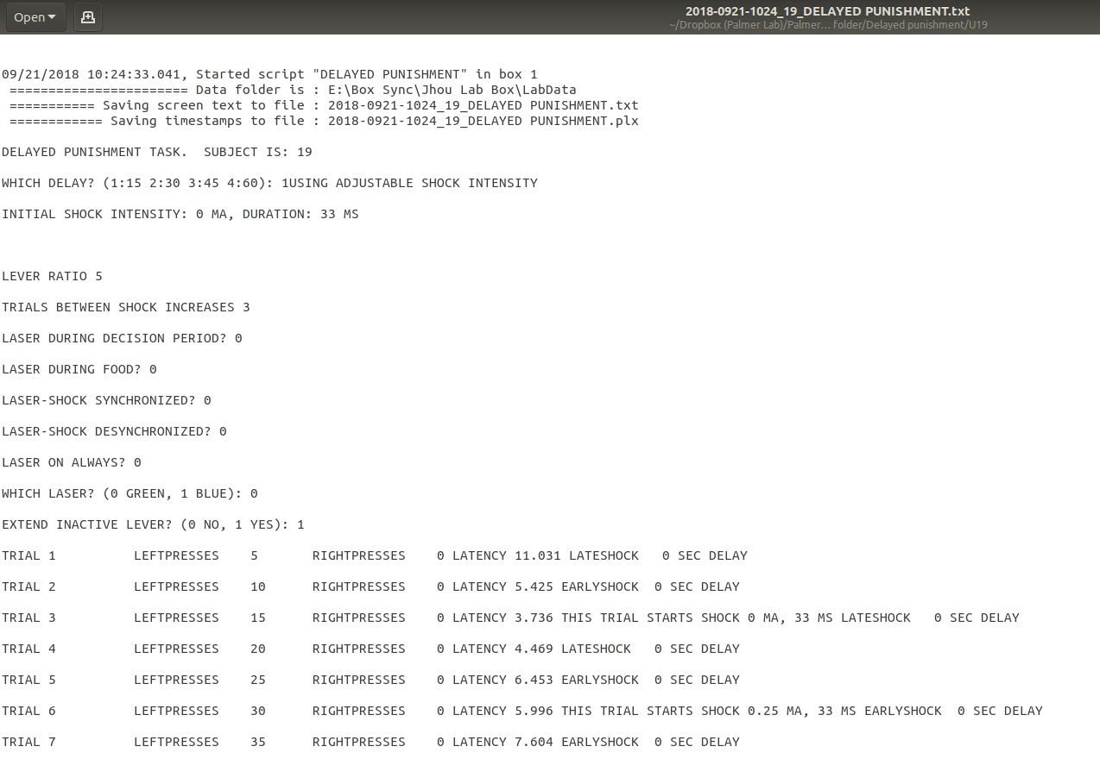

Difference between box and station? (No image)

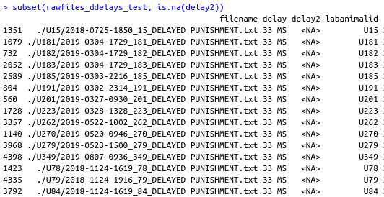

Delay cannot be extracted bc most of the time, there was no clear indication of delay or it says that it was adjustable (Some show 1 as 0, 0 as 0, or even nothing)

Which is more reliable? THIS TRIAL, extracting the first occurrence of _ SEC every line or extracting the coded WHICH DELAY? Line (Leaning toward former bc unsure about the consistency of the key)

What should I do with the above cases

(Cross referenced above and for example U191 doesn’t have any 3/2 data in the spreadsheet)